**TestNG Parallel Execution Exam**

|  |  |  |
| --- | --- | --- |
| **Question** | **Answer** | **Explanation** |
| **1** | **1** |  |
| **2** | **2** |  |
| **3** | **4** |  |
| **4** | **3** |  |
| **5** | **4** |  |
| **6** | **threadPoolSize = 3**  **invocationCount = 5** |  |
| **7** | **6** |  |
| **8** | **3** |  |
| **9** | **6** |  |
| **10** | **6** |  |

1. How many threads will be started when you run the test?

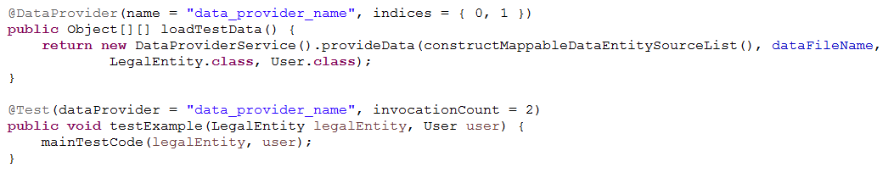

1. How many threads will be started when you run the test?

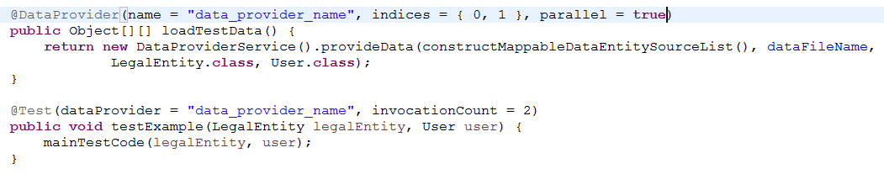

1. How many threads will be started when you run the test?

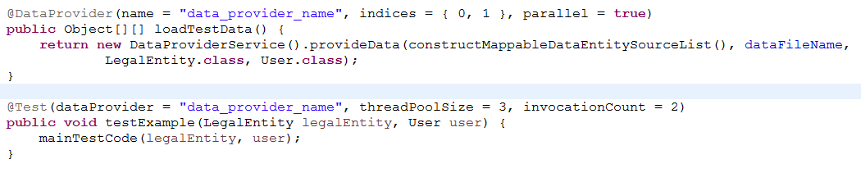

1. How many threads will be started when you run the test?

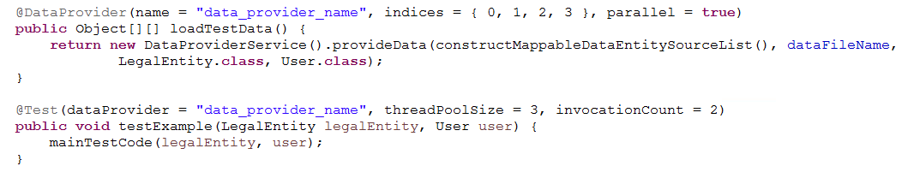

1. Explain the sequence of the execution (e.g. First the test will be executed with rows 4,5,6 after that due to invocation count …).

Adjust the current configuration so that the desired 12 runs (4 rows executed 3 times) are executed all at the same time in parallel.

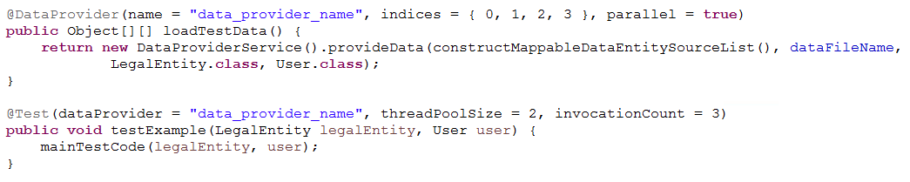

1. Adjust the @Test configuration so that 15 threads are executed in parallel.

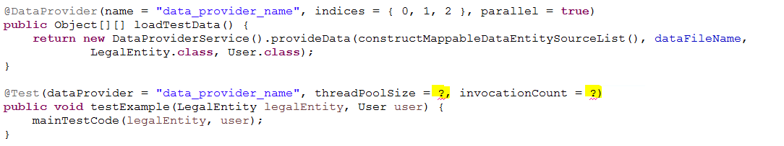

1. How many threads will be started in that case?

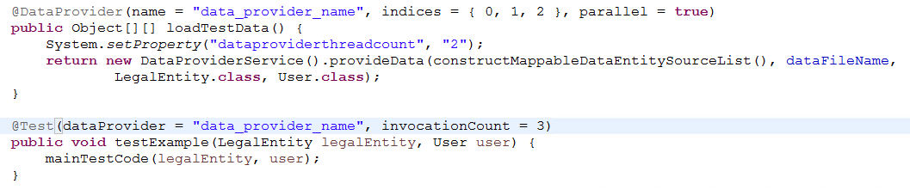

1. How many threads will be started in that case?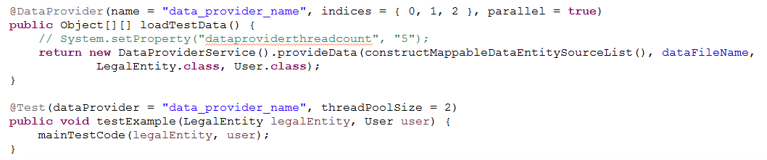
2. How many threads will be started in that case and **why**? 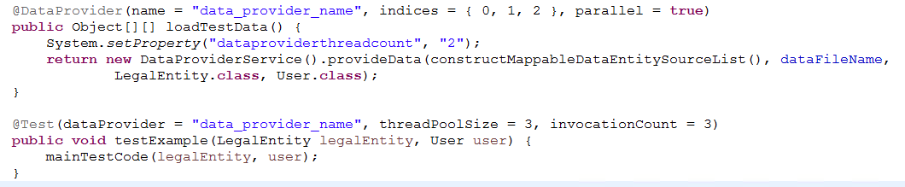
3. How many threads will be started in that case and **why**?

